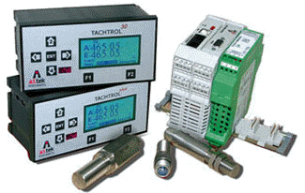
窗体顶端
 | FEATURES
- Improved instrument accuracy, processing speed and response time  - Frequency, period or counter modes  - Accepts bi-directional sensor inputs, decodes quadrature or direction signal logic  - 126 x 64 pixel LCD backlit display for speed, units, alarm status, security and programming (TACHTROL series)  - 4 relays with user-defined set points and behavior  - Analog output: 0 or 4 - 20mA, -20 to +20mA with use of bi-directional sensor |  | - Two programming methods: Front panel on display or USB2.0 connectivity to PC / Windows-based GUI (Graphical User Interface)  - Utility RS485 communication allows full GUI function (up to 8000 ft)  - Drives up to 8 remote displays (TTplus)  - Wide range of AC or DC power  - Environmentally hardened for temperature, vibration and shock  - EMC / CE compliant to current BS EN directives.  - RoHS Compliant

